“Build & Judge a Mini AI” task

**Part 1 — Chronology of AI: Real-World Examples**

* **Machine Learning →** Email spam filters that learn from labeled data.
* **Deep Learning →** AlphaGo defeating human champions in Go.
* **Computer Vision →** Face recognition in smartphone unlocking.
* **NLP →** Chatbots that understand and respond to customer queries.
* **LLMs →** ChatGPT generating human-like responses across topics.

**Part 2 — Deep Learning Architectures: Match the Model**

* **RNN →** Early speech-to-text systems
* **LSTM →** Text translation (old Google Translate)
* **CNN →** Image recognition
* **Transformer →** Predicting the next word in ChatGPT

**Part 3 — Frameworks**

* **Keras** — I’d use Keras because it’s beginner-friendly and lets students build a cat-vs-dog classifier with minimal code.

**Part 4 – Evaluation Metrics**

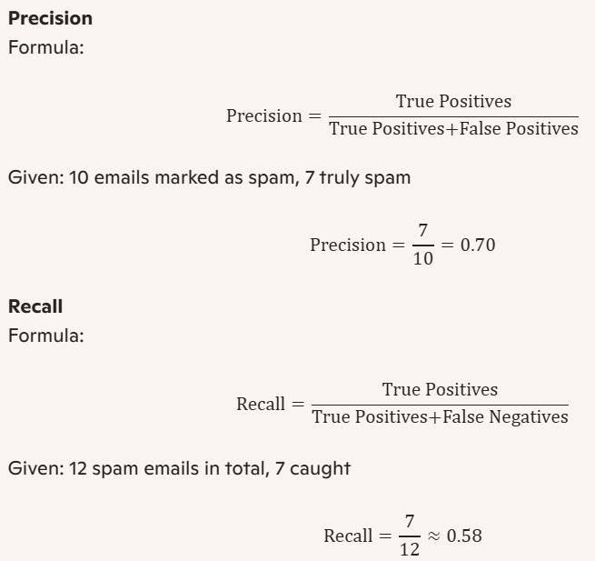

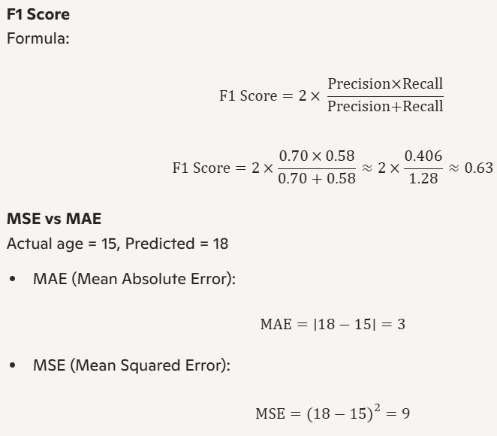

**BLEU vs ROUGE**

Original: “The cat sat on the mat”

AI Output: “Cat is on the mat”

BLEU focuses on exact n-gram matches, while ROUGE captures meaning overlap. ROUGE would likely give a higher score here due to semantic similarity.

**Part 5 – Responsible AI & Explainability**

If a customer asks why their loan was rejected, a fair and simple explanation could be: “Your income was too low compared to the loan amount requested.” Your loan application was reviewed based on several financial factors. The AI found that your monthly income was below the required threshold. This made it difficult to support the repayment of the requested loan amount. Additionally, your existing debts increased your financial risk. The credit score also fell short of our minimum criteria. These combined factors led to the rejection. Its encouraged that you try to improve these areas and reapply.